**What is a volunteer service?**

**Prepared Text 1**

**Volunteering**

/;

Volunteering is important for numerous reasons that benefit both the community and the volunteer themselves.

Volunteering is what makes a community because it brings people together to work on a goal. When a person donates their time, they give hope to someone who needs it. If a local family's house burnt down and a group of people hosted a benefit for them, that family's faith would be revived when they realized that people care.   
A volunteer also benefits themselves because they get to see how their contribution has made a difference. This experience contributes to personal development especially in areas such as self-fulfillment, self-confidence, and self-esteem. Knowing that you made a positive impact on someone is an emotionally uplifting experience that can never be matched by money or fame.  
These are just a few reasons why volunteering is important. Not only does it bring hope and happiness to people, but it also leads to spiritual and personal growth. It is an experience that cannot be bought with any amount of money.

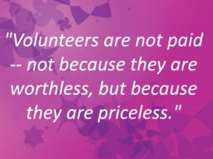

### Benefits of volunteering:

### 4 ways to feel healthier and happier

1. Volunteering connects you to others
2. Volunteering is good for your mind and body
3. Volunteering can advance your career
4. Volunteering brings fun and fulfillment to your life

### Where to find volunteer opportunities :

* Community theaters, museums, and monuments
* Libraries or senior centers
* Service organizations such as Lions Clubs or Rotary Clubs
* Local animal shelters, rescue organizations, or wildlife centers
* Youth organizations, sports teams, and after-school programs
* Historical restorations, national parks, and conservation organizations
* Places of worship such as churches or synagogues
* Online databases such as those contained in the Resources section below

## End up, Volunteering can help you make friends, learn new skills, advance your career, and even feel happier and healthier.

. 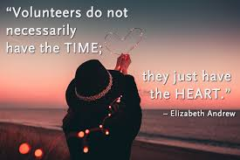

**Prepared Text 2**

BECOME A PART OF A GREAT TEAM

Come and join the Open House Thessaloniki group

Open House Thessaloniki is based on volunteering. The volunteers realize the project completely the days it lasts. The responsibilities that they have to take are: welcoming the public, touring, escorting the groups, product promotion, photography/video recording.

Fields, in which you can become a volunteer are the following

|  |  |
| --- | --- |
| Health | |
| Human Rights / Vulnerable Groups |
| Youth/ Child | |

|  |
| --- |
| Environment |

|  |
| --- |
| Culture / Arts / Creativity |

|  |
| --- |
| Other |

More information : <http://www.openhousethessaloniki.gr/en/events/>

**Prepared Text 3**

#### NEW VOLUNTEER?

##### THE FOLLOWING INFO IS REQUIRED

Name & Surname*

|  |
| --- |
|  |

E-Mail*

|  |
| --- |
|  |

Telephone Number*

|  |
| --- |
|  |

Area / Region where you would like to offer Support*

|  |
| --- |
|  |

Submit.

**Prepared Text 4**

**Thessaloniki IFF - Volunteers Program**

The Volunteers Program of the Thessaloniki IFF is organized on the occasion of the two main events held annually by the TIFF Institution; the TIFF (Thessaloniki International Film Festival) taking place each November and the TDF (Thessaloniki Documentary Festival) held every March .

Each year the applicants outnumber by far the volunteers the festival needs; this constantly growing demand demonstrates that the Volunteers Program continues to fascinate Thessaloniki’s film buffs.

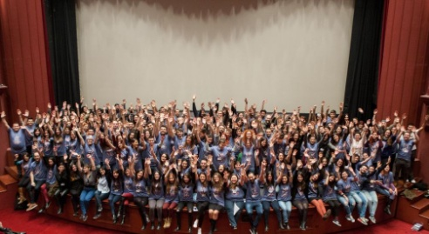 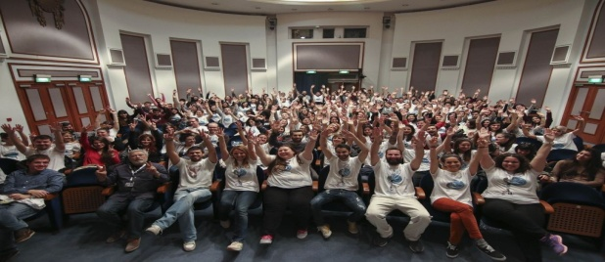

More information :

<https://www.filmfestival.gr/en/departments/16>

**Ethelon**



With ethelon program you can participate in social activities in various non- profit organizations as well as gain access to events of your own interest.

### Ethelon connects volunteers with the organizers of various events and actions, undertaking all the stages of this process and training volunteers appropriately on the need and the peculiarities of each event or action.

With a very easy process you can also sign up to the ethelon platform and create your own profile with your interests and abilities, and then declare your interest in the various events that taking place.

More information :

<http://www.ethelon.org/>

**Prepared Text 5**

**METAdrasi**

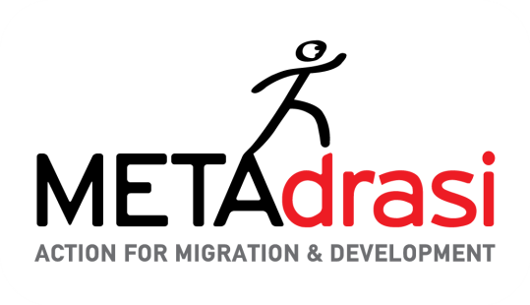

METAdrasi is an action for migration and development.

### Join METAdrasi’s team of volunteers!

METAdrasi has trust in the valuable support of committed volunteers in a number of activities, including the organization and distribution of humanitarian aid, the safe escorting of unaccompanied minors, educational and recreational activities with children and administrative support in our central offices.

If you have time, energy and motivation to offer then you are welcome as a volunteer!

Your help is valuable:

* In the school
* In Greek language courses for adults
* In mother & child areas
* In unaccompanied minor’s escorting missions
* In humanitarian aid missions
* In the office.

You can contact the Volunteers’ Department by phone at 214 100 8700 – direct 254 or e-mail at    [volunteer@metadrasi.org](mailto:volunteer@metadrasi.org) .